# PRACTICAL FILE

# OF

**Programming in PHP Lab**

**SUBJECT CODE- UGCA1930**



### Submitted By: Submitted To:

**Sapreet Singh Prof. Mandeep Kaur Bara**

**Uni. Roll no.-2001150 Branch: BCA Semester: 5 th**

**DEPARTMENT OF COMPUTER SCIENCE & ENGINEERING BABA BANDA SINGH BAHADUR ENGINEERING COLLEGE FATEHGARH SAHIB**

INDEX

|  |  |  |  |  |
| --- | --- | --- | --- | --- |
| **S.No.** | **Practicals** | **Page no.** | **Signature** | **Date** |
| 1. | Take values from the user and compute sum, subtraction,  multiplication, division and exponent of value of the  variables. |  |  |  |
| 2. | Write a program to find area of following shapes: circle,  rectangle, triangle, square, trapezoid and parallelogram. |  |  |  |
| 3. | Compute and print roots of quadratic equation. |  |  |  |
| 4. | Write a program to determine whether a triangle is isosceles or not? |  |  |  |
| 5. | Print multiplication table of a number input by the user. |  |  |  |
| 6. | Calculate sum of natural numbers from one to n number. |  |  |  |
| 7. | Print Fibonacci series up to n numbers e.g. 0 1 1 2 3 5 8 13 21…..n . |  |  |  |
| 8. | Write a program to find the factorial of any number. |  |  |  |
| 9. | Determine prime numbers within a specific range. |  |  |  |
| 10. | Write a program to compute, the Average and Grade of students marks. |  |  |  |
| 11. | Compute addition, subtraction and multiplication of a matrix. |  |  |  |
| 12. | Count total number of vowels in a word “Develop & Empower Individuals”. |  |  |  |
| 13. | Determine whether a string is palindrome or not? |  |  |  |
| 14. | Display word after Sorting in alphabetical order. |  |  |  |
| 15. | Check whether a number is in a given range using functions. |  |  |  |
| 16. | Write a program accepts a string and calculates number of upper case letters and lower case letters available in that string. |  |  |  |
| 17. | Design a program to reverse a string word by word. |  |  |  |
| 18. | Write a program to create a login form. On submitting the form, the user should navigate to profile page. |  |  |  |
| 19. | Design front page of a college or department using graphics method. |  |  |  |
| 20. | Write a program to upload and download files. |  |  |  |

**Aim: 1**.Take values from the user and compute sum, subtraction, multiplication,

division and exponent of value of the variables.

**Input :-**

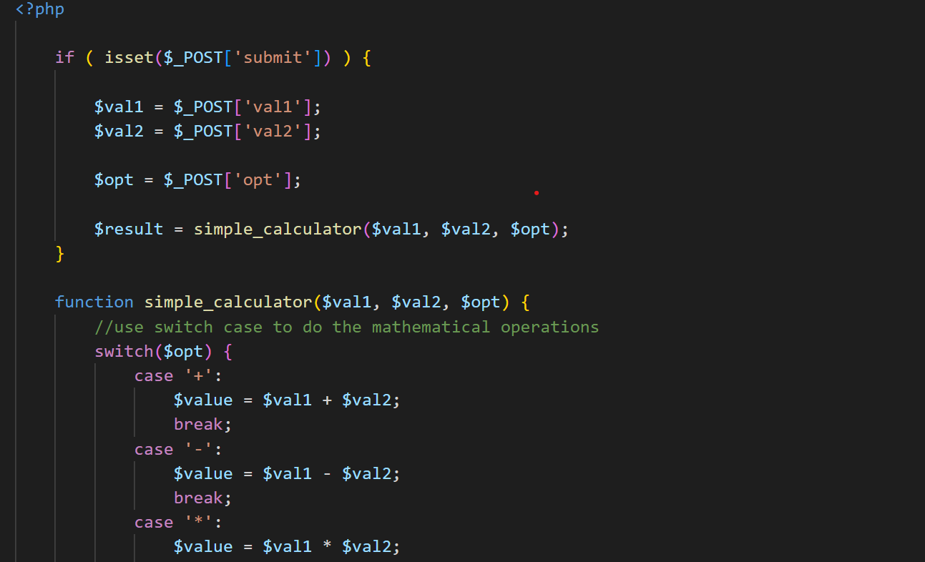

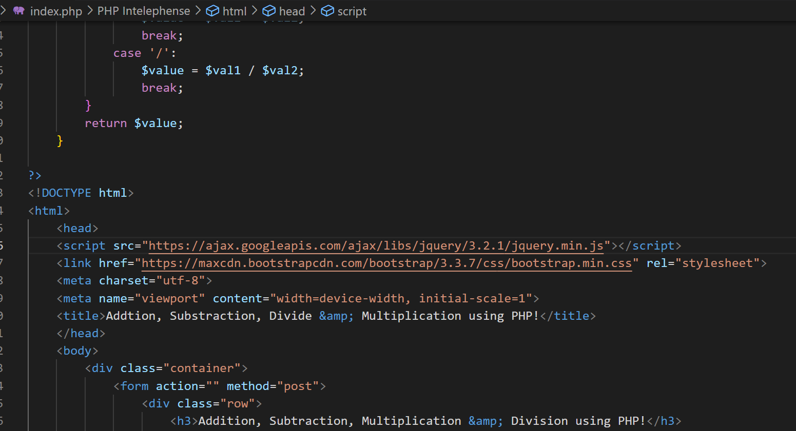

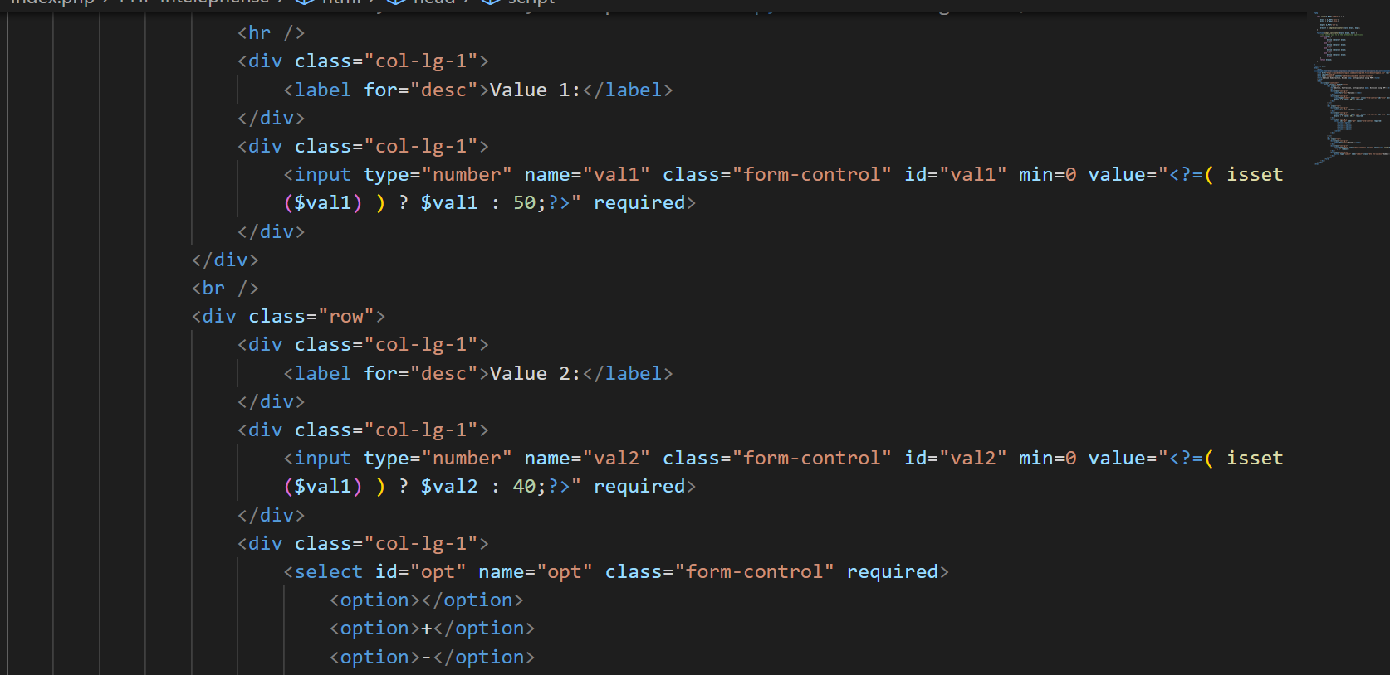

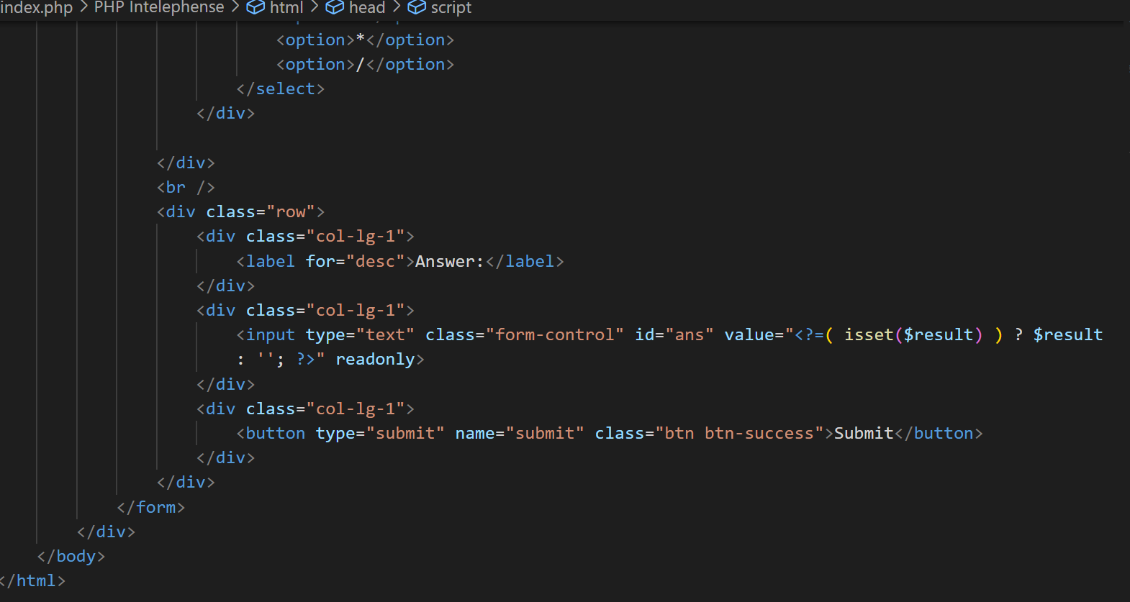

Output :-

